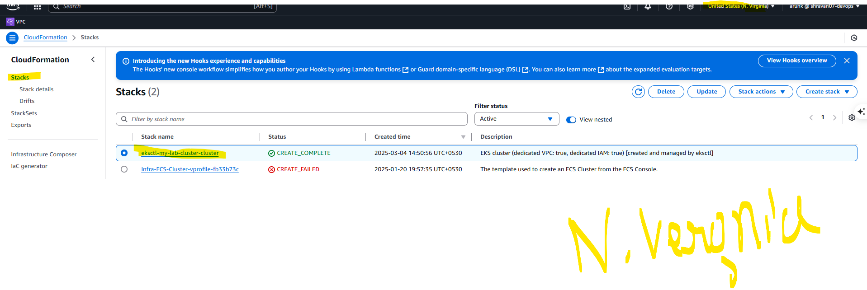
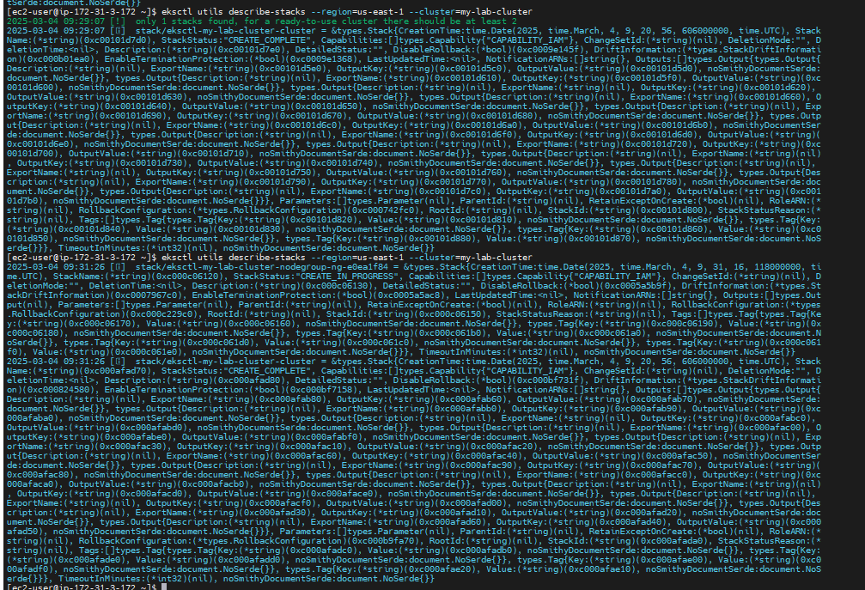

[ec2-user@ip-172-31-3-172 ~]$ eksctl create cluster --name my-lab-cluster --region us-east-1 --node-type t2.medium
2025-03-04 09:18:52 [?] eksctl version 0.204.0
2025-03-04 09:18:52 [?] using region us-east-1
2025-03-04 09:18:53 [?] setting availability zones to [us-east-1a us-east-1f]
2025-03-04 09:18:53 [?] subnets for us-east-1a - public:192.168.0.0/19 private:192.168.64.0/19
2025-03-04 09:18:53 [?] subnets for us-east-1f - public:192.168.32.0/19 private:192.168.96.0/19
2025-03-04 09:18:53 [?] nodegroup "ng-61b03a3e" will use "" [AmazonLinux2/1.30]
2025-03-04 09:18:53 [?] using Kubernetes version 1.30
2025-03-04 09:18:53 [?] creating EKS cluster "my-lab-cluster" in "us-east-1" region with managed nodes
2025-03-04 09:18:53 [?] will create 2 separate CloudFormation stacks for cluster itself and the initial managed nodegroup
2025-03-04 09:18:53 [?] if you encounter any issues, check CloudFormation console or try 'eksctl utils describe-stacks --region=us-east-1 --cluster=my-lab-cluster'
2025-03-04 09:18:53 [?] Kubernetes API endpoint access will use default of {publicAccess=true, privateAccess=false} for cluster "my-lab-cluster" in "us-east-1"
2025-03-04 09:18:53 [?] CloudWatch logging will not be enabled for cluster "my-lab-cluster" in "us-east-1"
2025-03-04 09:18:53 [?] you can enable it with 'eksctl utils update-cluster-logging --enable-types={SPECIFY-YOUR-LOG-TYPES-HERE (e.g. all)} --region=us-east-1 --cluster=my-lab-cluster'
2025-03-04 09:18:53 [?] default addons vpc-cni, kube-proxy, coredns, metrics-server were not specified, will install them as EKS addons
2025-03-04 09:18:53 [?]
2 sequential tasks: { create cluster control plane "my-lab-cluster",
2 sequential sub-tasks: {
2 sequential sub-tasks: {
1 task: { create addons },
wait for control plane to become ready,
},
create managed nodegroup "ng-61b03a3e",
}
}
2025-03-04 09:18:53 [?] building cluster stack "eksctl-my-lab-cluster-cluster"
2025-03-04 09:18:54 [!] 1 error(s) occurred and cluster hasn't been created properly, you may wish to check CloudFormation console
2025-03-04 09:18:54 [?] to cleanup resources, run 'eksctl delete cluster --region=us-east-1 --name=my-lab-cluster'
2025-03-04 09:18:54 [?] creating CloudFormation stack "eksctl-my-lab-cluster-cluster": operation error CloudFormation: CreateStack, https response error StatusCode: 400, RequestID: c73be74c-50fb-48bb-a02a-9cc4b3d3a9ef, AlreadyExistsException: Stack [eksctl-my-lab-cluster-cluster] already exists
Error: failed to create cluster "my-lab-cluster"
[ec2-user@ip-172-31-3-172 ~]$ eksctl delete cluster --region=us-east-1 --name=my-lab-cluster
Error: unable to describe cluster control plane: operation error EKS: DescribeCluster, https response error StatusCode: 404, RequestID: 46aa3143-bf83-4209-adbd-77b3ca6617d8, ResourceNotFoundException: No cluster found for name: my-lab-cluster

[ec2-user@ip-172-31-3-172 ~]$ eksctl create cluster --name my-lab-cluster --region us-east-1 --node-type t2.medium
2025-03-04 09:19:37 [?] eksctl version 0.204.0
2025-03-04 09:19:37 [?] using region us-east-1
2025-03-04 09:19:38 [?] setting availability zones to [us-east-1c us-east-1d]
2025-03-04 09:19:38 [?] subnets for us-east-1c - public:192.168.0.0/19 private:192.168.64.0/19
2025-03-04 09:19:38 [?] subnets for us-east-1d - public:192.168.32.0/19 private:192.168.96.0/19
2025-03-04 09:19:38 [?] nodegroup "ng-dd718e95" will use "" [AmazonLinux2/1.30]
2025-03-04 09:19:38 [?] using Kubernetes version 1.30
2025-03-04 09:19:38 [?] creating EKS cluster "my-lab-cluster" in "us-east-1" region with managed nodes
2025-03-04 09:19:38 [?] will create 2 separate CloudFormation stacks for cluster itself and the initial managed nodegroup
2025-03-04 09:19:38 [?] if you encounter any issues, check CloudFormation console or try 'eksctl utils describe-stacks --region=us-east-1 --cluster=my-lab-cluster'
2025-03-04 09:19:38 [?] Kubernetes API endpoint access will use default of {publicAccess=true, privateAccess=false} for cluster "my-lab-cluster" in "us-east-1"
2025-03-04 09:19:38 [?] CloudWatch logging will not be enabled for cluster "my-lab-cluster" in "us-east-1"
2025-03-04 09:19:38 [?] you can enable it with 'eksctl utils update-cluster-logging --enable-types={SPECIFY-YOUR-LOG-TYPES-HERE (e.g. all)} --region=us-east-1 --cluster=my-lab-cluster'
2025-03-04 09:19:38 [?] default addons vpc-cni, kube-proxy, coredns, metrics-server were not specified, will install them as EKS addons
2025-03-04 09:19:38 [?]
2 sequential tasks: { create cluster control plane "my-lab-cluster",
2 sequential sub-tasks: {
2 sequential sub-tasks: {
1 task: { create addons },
wait for control plane to become ready,
},
create managed nodegroup "ng-dd718e95",
}
}
2025-03-04 09:19:38 [?] building cluster stack "eksctl-my-lab-cluster-cluster"
2025-03-04 09:19:39 [!] 1 error(s) occurred and cluster hasn't been created properly, you may wish to check CloudFormation console
2025-03-04 09:19:39 [?] to cleanup resources, run 'eksctl delete cluster --region=us-east-1 --name=my-lab-cluster'
2025-03-04 09:19:39 [?] creating CloudFormation stack "eksctl-my-lab-cluster-cluster": operation error CloudFormation: CreateStack, https response error StatusCode: 400, RequestID: 40d9b970-1d31-4f24-aa8a-2a04f2ce8b29, AlreadyExistsException: Stack [eksctl-my-lab-cluster-cluster] already exists
Error: failed to create cluster "my-lab-cluster"
[ec2-user@ip-172-31-3-172 ~]$ df -h
Filesystem Size Used Avail Use% Mounted on
devtmpfs 4.0M 0 4.0M 0% /dev
tmpfs 2.0G 0 2.0G 0% /dev/shm
tmpfs 781M 476K 781M 1% /run
/dev/xvda1 8.0G 5.7G 2.4G 71% /
tmpfs 2.0G 0 2.0G 0% /tmp
/dev/xvda128 10M 1.3M 8.7M 13% /boot/efi
tmpfs 391M 0 391M 0% /run/user/1000

[ec2-user@ip-172-31-3-172 ~]$ eksctl create cluster --name my-lab-cluster --region us-east-1 --node-type t2.medium
2025-03-04 09:20:54 [?] eksctl version 0.204.0
2025-03-04 09:20:54 [?] using region us-east-1
2025-03-04 09:20:55 [?] setting availability zones to [us-east-1b us-east-1f]
2025-03-04 09:20:55 [?] subnets for us-east-1b - public:192.168.0.0/19 private:192.168.64.0/19
2025-03-04 09:20:55 [?] subnets for us-east-1f - public:192.168.32.0/19 private:192.168.96.0/19
2025-03-04 09:20:55 [?] nodegroup "ng-e0ea1f84" will use "" [AmazonLinux2/1.30]
2025-03-04 09:20:55 [?] using Kubernetes version 1.30
2025-03-04 09:20:55 [?] creating EKS cluster "my-lab-cluster" in "us-east-1" region with managed nodes
2025-03-04 09:20:55 [?] will create 2 separate CloudFormation stacks for cluster itself and the initial managed nodegroup
2025-03-04 09:20:55 [?] if you encounter any issues, check CloudFormation console or try 'eksctl utils describe-stacks --region=us-east-1 --cluster=my-lab-cluster'
2025-03-04 09:20:55 [?] Kubernetes API endpoint access will use default of {publicAccess=true, privateAccess=false} for cluster "my-lab-cluster" in "us-east-1"
2025-03-04 09:20:55 [?] CloudWatch logging will not be enabled for cluster "my-lab-cluster" in "us-east-1"
2025-03-04 09:20:55 [?] you can enable it with 'eksctl utils update-cluster-logging --enable-types={SPECIFY-YOUR-LOG-TYPES-HERE (e.g. all)} --region=us-east-1 --cluster=my-lab-cluster'
2025-03-04 09:20:55 [?] default addons metrics-server, vpc-cni, kube-proxy, coredns were not specified, will install them as EKS addons
2025-03-04 09:20:55 [?]
2 sequential tasks: { create cluster control plane "my-lab-cluster",
2 sequential sub-tasks: {
2 sequential sub-tasks: {
1 task: { create addons },
wait for control plane to become ready,
},
create managed nodegroup "ng-e0ea1f84",
}
}
2025-03-04 09:20:55 [?] building cluster stack "eksctl-my-lab-cluster-cluster"
2025-03-04 09:20:56 [?] deploying stack "eksctl-my-lab-cluster-cluster"
2025-03-04 09:21:26 [?] waiting for CloudFormation stack "eksctl-my-lab-cluster-cluster"
2025-03-04 09:21:57 [?] waiting for CloudFormation stack "eksctl-my-lab-cluster-cluster"
2025-03-04 09:22:58 [?] waiting for CloudFormation stack "eksctl-my-lab-cluster-cluster"
2025-03-04 09:23:59 [?] waiting for CloudFormation stack "eksctl-my-lab-cluster-cluster"
2025-03-04 09:24:59 [?] waiting for CloudFormation stack "eksctl-my-lab-cluster-cluster"
2025-03-04 09:26:00 [?] waiting for CloudFormation stack "eksctl-my-lab-cluster-cluster"
2025-03-04 09:27:01 [?] waiting for CloudFormation stack "eksctl-my-lab-cluster-cluster"
2025-03-04 09:28:02 [?] waiting for CloudFormation stack "eksctl-my-lab-cluster-cluster"
2025-03-04 09:29:03 [?] waiting for CloudFormation stack "eksctl-my-lab-cluster-cluster"
2025-03-04 09:29:07 [?] creating addon: metrics-server
2025-03-04 09:29:07 [?] successfully created addon: metrics-server
2025-03-04 09:29:08 [!] recommended policies were found for "vpc-cni" addon, but since OIDC is disabled on the cluster, eksctl cannot configure the requested permissions; the recommended way to provide IAM permissions for "vpc-cni" addon is via pod identity associations; after addon creation is completed, add all recommended policies to the config file, under `addon.PodIdentityAssociations`, and run `eksctl update addon`
2025-03-04 09:29:08 [?] creating addon: vpc-cni
2025-03-04 09:29:08 [?] successfully created addon: vpc-cni
2025-03-04 09:29:09 [?] creating addon: kube-proxy
2025-03-04 09:29:10 [?] successfully created addon: kube-proxy
2025-03-04 09:29:10 [?] creating addon: coredns
2025-03-04 09:29:11 [?] successfully created addon: coredns
2025-03-04 09:31:15 [?] building managed nodegroup stack "eksctl-my-lab-cluster-nodegroup-ng-e0ea1f84"
2025-03-04 09:31:16 [?] deploying stack "eksctl-my-lab-cluster-nodegroup-ng-e0ea1f84"
2025-03-04 09:31:16 [?] waiting for CloudFormation stack "eksctl-my-lab-cluster-nodegroup-ng-e0ea1f84"
2025-03-04 09:31:47 [?] waiting for CloudFormation stack "eksctl-my-lab-cluster-nodegroup-ng-e0ea1f84"
2025-03-04 09:32:19 [?] waiting for CloudFormation stack "eksctl-my-lab-cluster-nodegroup-ng-e0ea1f84"
2025-03-04 09:33:02 [?] waiting for CloudFormation stack "eksctl-my-lab-cluster-nodegroup-ng-e0ea1f84"
2025-03-04 09:33:57 [?] waiting for CloudFormation stack "eksctl-my-lab-cluster-nodegroup-ng-e0ea1f84"
2025-03-04 09:35:10 [?] waiting for CloudFormation stack "eksctl-my-lab-cluster-nodegroup-ng-e0ea1f84"
2025-03-04 09:35:10 [?] waiting for the control plane to become ready
2025-03-04 09:35:21 [?] saved kubeconfig as "/home/ec2-user/.kube/config"
2025-03-04 09:35:21 [?] no tasks
2025-03-04 09:35:21 [?] all EKS cluster resources for "my-lab-cluster" have been created
2025-03-04 09:35:22 [?] nodegroup "ng-e0ea1f84" has 2 node(s)
2025-03-04 09:35:22 [?] node "ip-192-168-10-178.ec2.internal" is ready
2025-03-04 09:35:22 [?] node "ip-192-168-40-189.ec2.internal" is ready
2025-03-04 09:35:22 [?] waiting for at least 2 node(s) to become ready in "ng-e0ea1f84"
2025-03-04 09:35:22 [?] nodegroup "ng-e0ea1f84" has 2 node(s)
2025-03-04 09:35:22 [?] node "ip-192-168-10-178.ec2.internal" is ready
2025-03-04 09:35:22 [?] node "ip-192-168-40-189.ec2.internal" is ready
2025-03-04 09:35:22 [?] created 1 managed nodegroup(s) in cluster "my-lab-cluster"
2025-03-04 09:35:24 [?] kubectl command should work with "/home/ec2-user/.kube/config", try 'kubectl get nodes'
2025-03-04 09:35:24 [?] EKS cluster "my-lab-cluster" in "us-east-1" region is ready

[ec2-user@ip-172-31-3-172 ~]$ kubectl get nodes
NAME STATUS ROLES AGE VERSION
ip-192-168-10-178.ec2.internal Ready <none> 4m48s v1.30.9-eks-5d632ec
ip-192-168-40-189.ec2.internal Ready <none> 4m50s v1.30.9-eks-5d632ec
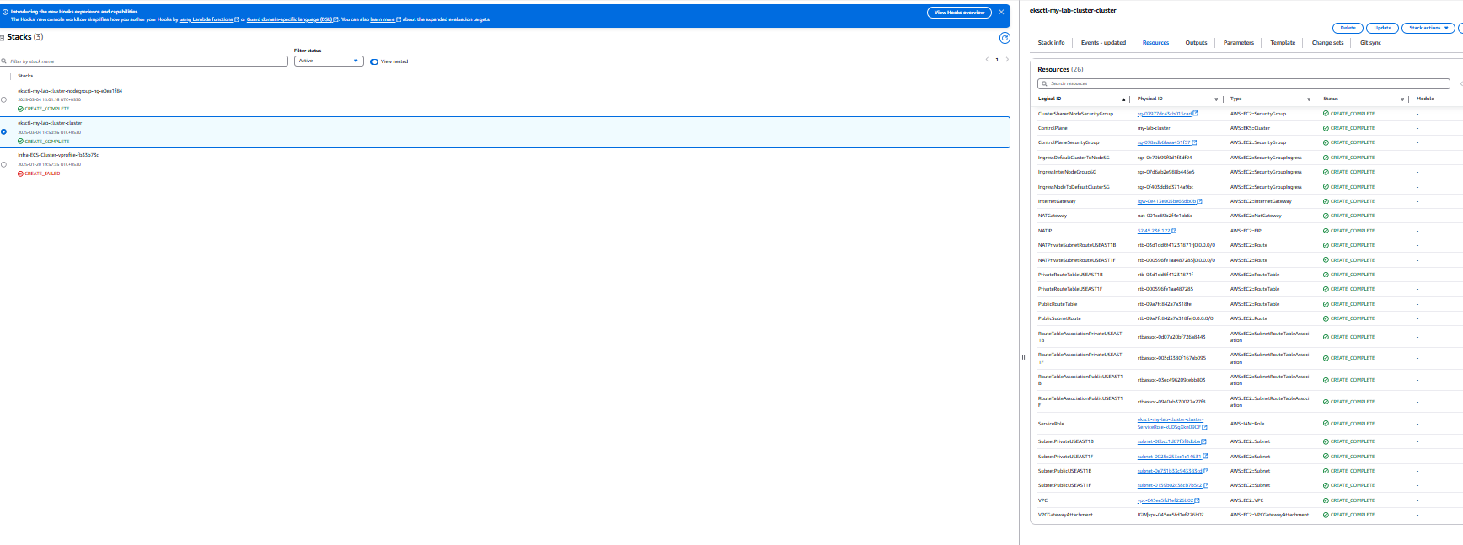
[ec2-user@ip-172-31-3-172 ~]$

delete eks steps:::::::::::::::::::::::::
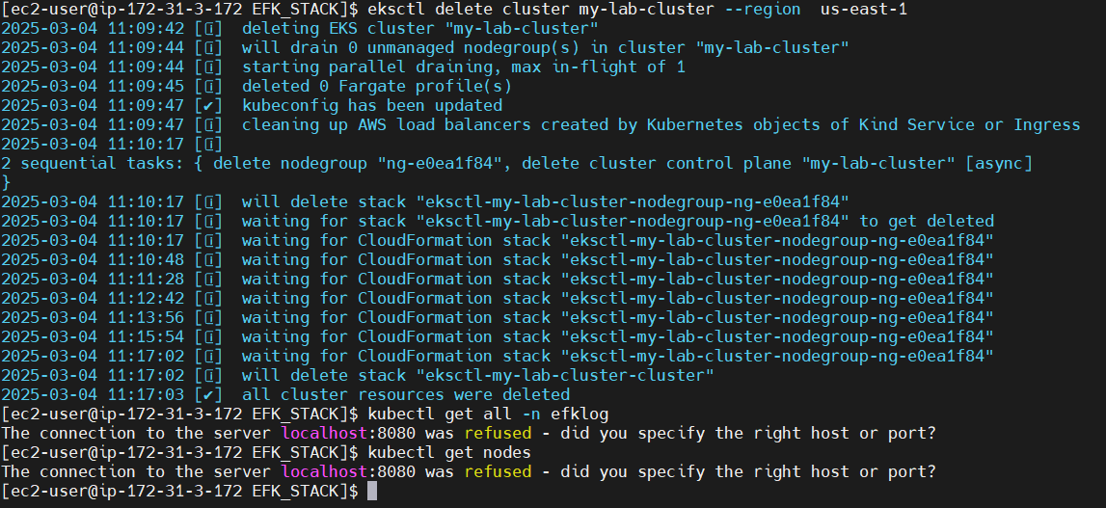
[ec2-user@ip-172-31-3-172 EFK_STACK]$ eksctl delete cluster my-lab-cluster --region us-east-1
2025-03-04 11:09:42 [ℹ] deleting EKS cluster "my-lab-cluster"
2025-03-04 11:09:44 [ℹ] will drain 0 unmanaged nodegroup(s) in cluster "my-lab-cluster"
2025-03-04 11:09:44 [ℹ] starting parallel draining, max in-flight of 1
2025-03-04 11:09:45 [ℹ] deleted 0 Fargate profile(s)
2025-03-04 11:09:47 [✔] kubeconfig has been updated
2025-03-04 11:09:47 [ℹ] cleaning up AWS load balancers created by Kubernetes objects of Kind Service or Ingress
2025-03-04 11:10:17 [ℹ]
2 sequential tasks: { delete nodegroup "ng-e0ea1f84", delete cluster control plane "my-lab-cluster" [async]
}
2025-03-04 11:10:17 [ℹ] will delete stack "eksctl-my-lab-cluster-nodegroup-ng-e0ea1f84"
2025-03-04 11:10:17 [ℹ] waiting for stack "eksctl-my-lab-cluster-nodegroup-ng-e0ea1f84" to get deleted
2025-03-04 11:10:17 [ℹ] waiting for CloudFormation stack "eksctl-my-lab-cluster-nodegroup-ng-e0ea1f84"
2025-03-04 11:10:48 [ℹ] waiting for CloudFormation stack "eksctl-my-lab-cluster-nodegroup-ng-e0ea1f84"
2025-03-04 11:11:28 [ℹ] waiting for CloudFormation stack "eksctl-my-lab-cluster-nodegroup-ng-e0ea1f84"
2025-03-04 11:12:42 [ℹ] waiting for CloudFormation stack "eksctl-my-lab-cluster-nodegroup-ng-e0ea1f84"
2025-03-04 11:13:56 [ℹ] waiting for CloudFormation stack "eksctl-my-lab-cluster-nodegroup-ng-e0ea1f84"
2025-03-04 11:15:54 [ℹ] waiting for CloudFormation stack "eksctl-my-lab-cluster-nodegroup-ng-e0ea1f84"
2025-03-04 11:17:02 [ℹ] waiting for CloudFormation stack "eksctl-my-lab-cluster-nodegroup-ng-e0ea1f84"
2025-03-04 11:17:02 [ℹ] will delete stack "eksctl-my-lab-cluster-cluster"
2025-03-04 11:17:03 [✔] all cluster resources were deleted
[ec2-user@ip-172-31-3-172 EFK_STACK]$ kubectl get all -n efklog
The connection to the server localhost:8080 was refused - did you specify the right host or port?
[ec2-user@ip-172-31-3-172 EFK_STACK]$ kubectl get nodes
The connection to the server localhost:8080 was refused - did you specify the right host or port?

